How to get PO soft copy in CG1

For ThinkPad User

1-1, find Internet Explorer, right click to “Run as administrator” 🡪 click “Yes” to proceed.

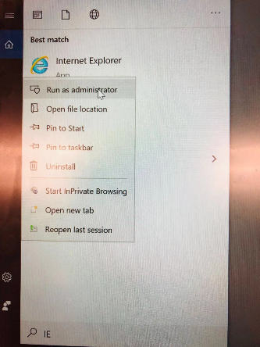

For Mac User

1-2, use Firefox.

2, open CG1 system

<https://wwwin-cg1prd.cisco.com/OA_HTML/OA.jsp?OAFunc=OAHOMEPAGE>

go “CISCO GLB PUR INQUIRY” 🡪 “Reports” 🡪 “Run”.

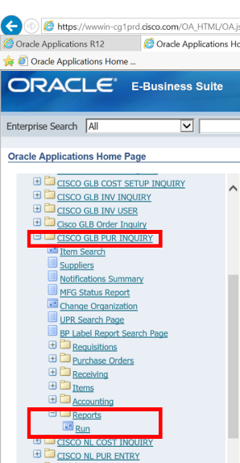

3, give Oracle 3-5mins to pop-up Java 🡪 click “OK”.

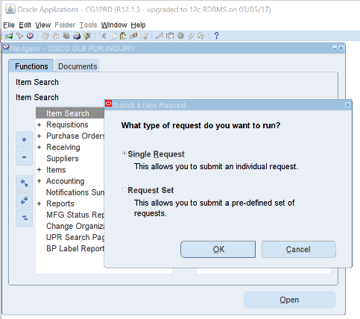

4, click box behind Name, input/choose “Cisco Email Printed PO Report” 🡪 click “OK”.

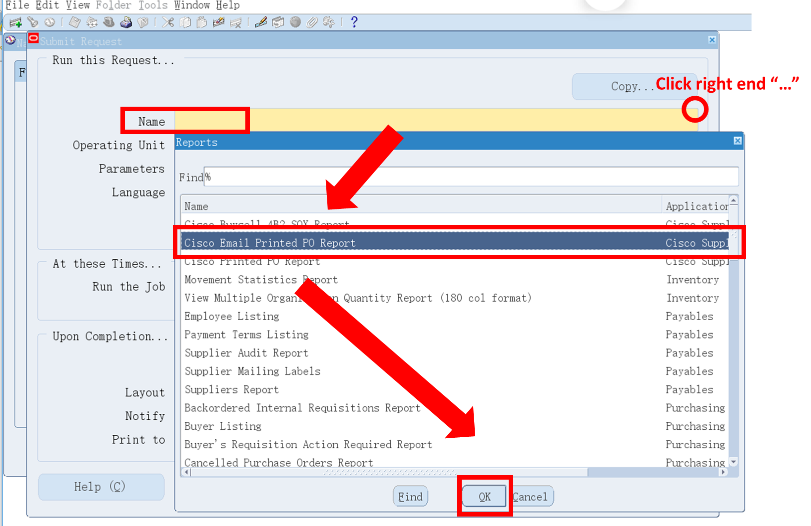

5, Operating Unit window should automatically pop-up (if not, click its box right end “…”) 🡪 5-1, input/choose “NETHERLANDS Operating” if your PO starts with **“555”** 🡪 click “OK”.

5-2, input/choose “CISCO US OPERATING UNIT” if your PO starts with **“202”** 🡪 click “OK”.

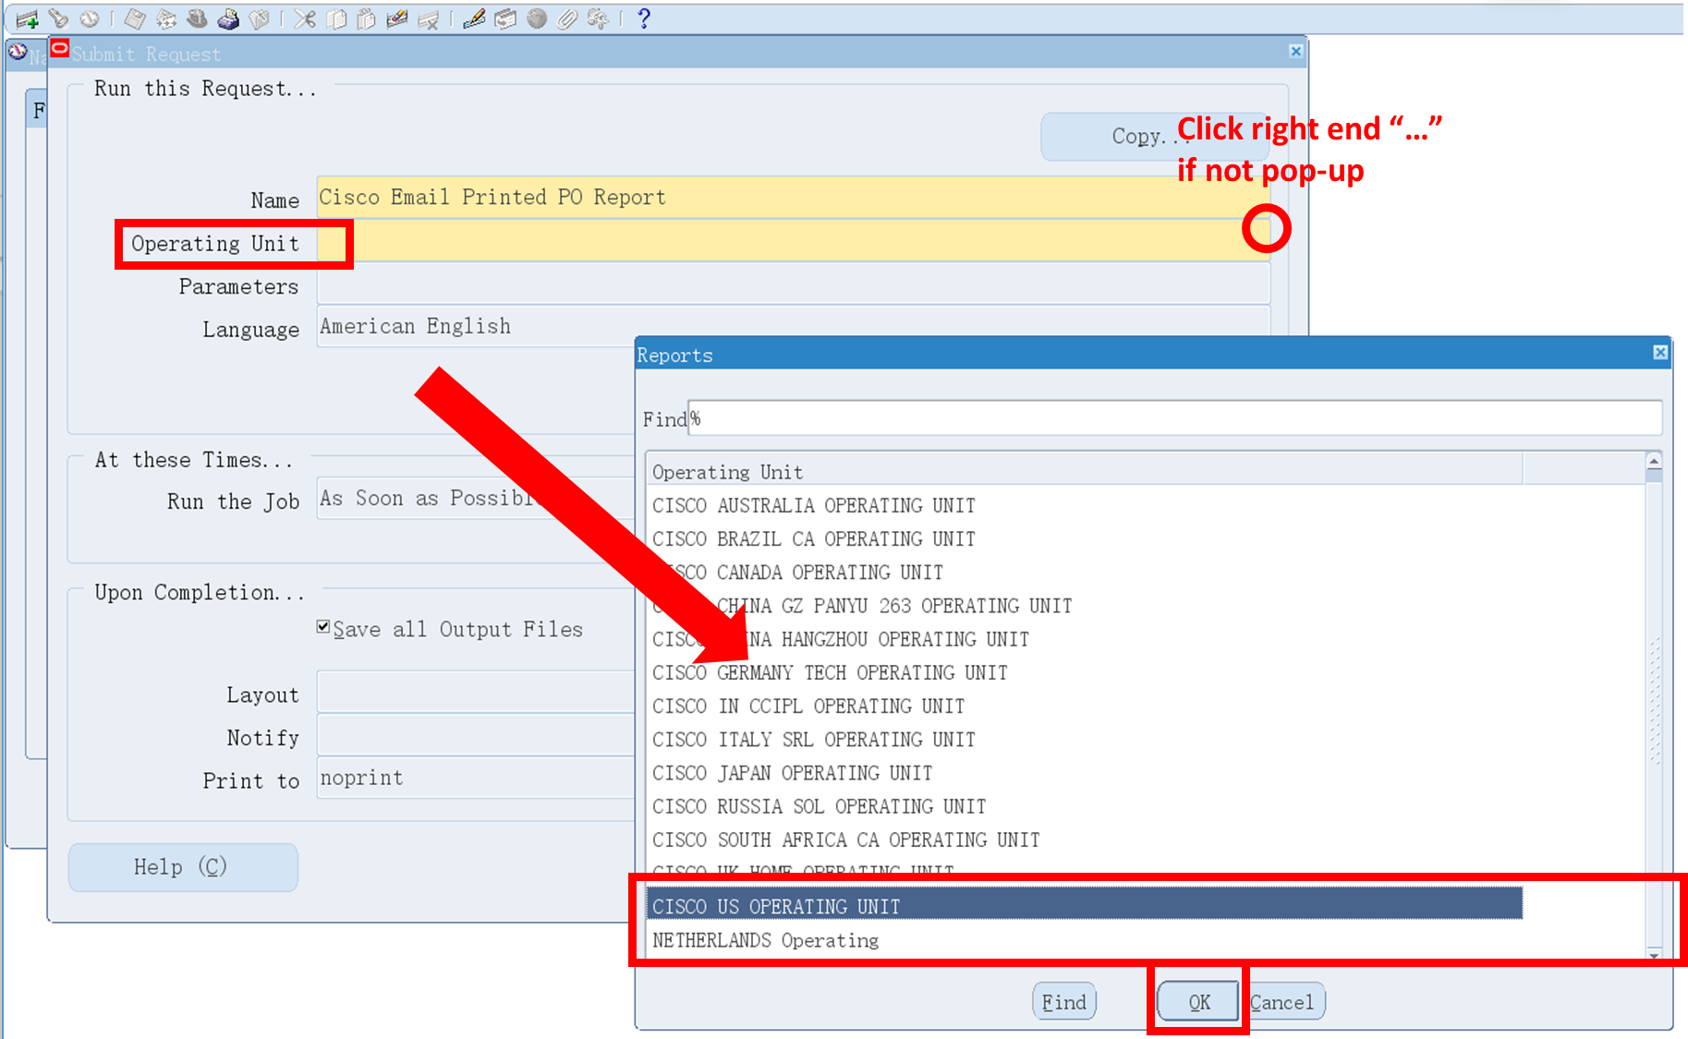

6, Parameters window should automatically pop-up (if not, click it) 🡪 input PO Number (same for From, To) 🡪 input “All” 🡪 input Email_Id [example@cisco.com](mailto:example@cisco.com) 🡪 click “OK”.

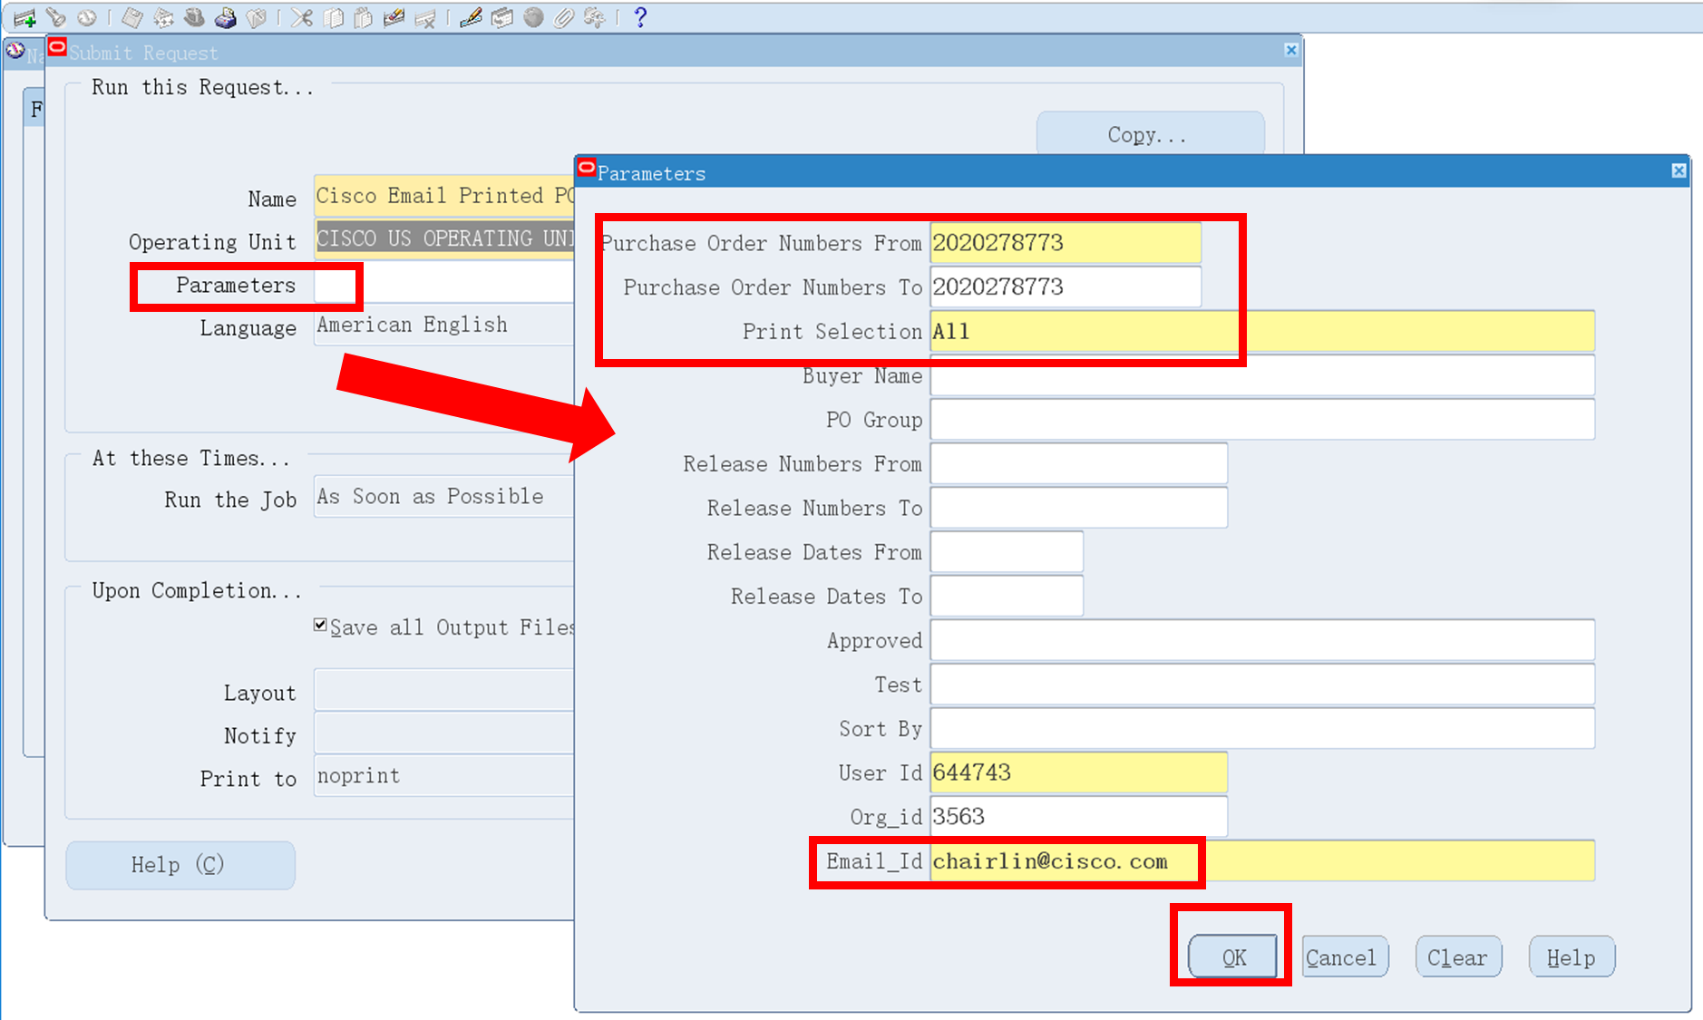

6, Click “Submit” 🡪 if no more PO softcopy needed, click “No”

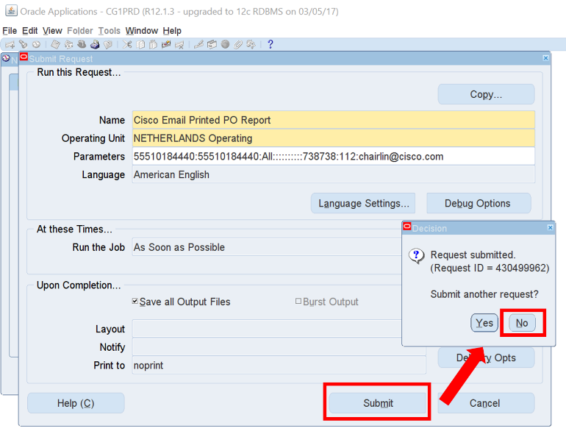

7, if more POs needed, click “Yes”, back to setting 🡪 click Parameters 🡪 input PO Number (this is the only thing you need to change) 🡪 click “OK” 🡪 click “Submit”.

8, PO sent via mail.